**Learning Outcomes**

1. Adding Tab Layout
2. Understanding Intents
3. Webview and Options Menu

**Intents**

An Intent is an abstract concept for some sort of operation that should be performed in the Android OS. It's often used to launch external applications with the *intent* to do something, such as make a phone call, display a web page, or map an address. As such, an Intent generally has two pieces of information associated with it; first, what the intent is (as in make a phone call), and second, what data does the intent need (such as a phone number) to perform the intention.

**Intent Example**

Design a layout as shown in the diagram

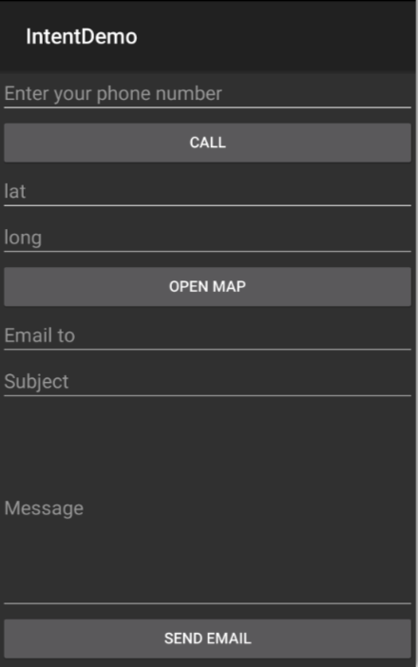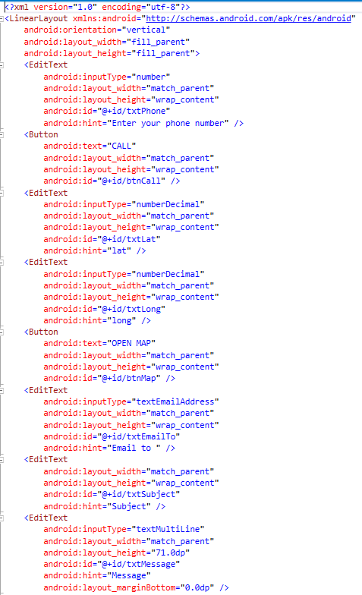

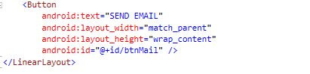

**MainActivity.cs**

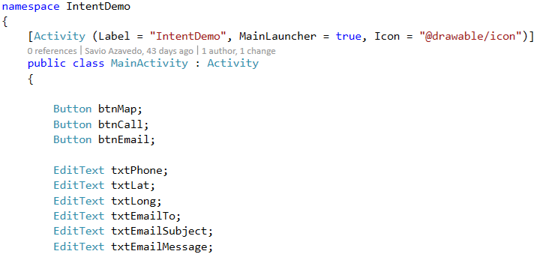

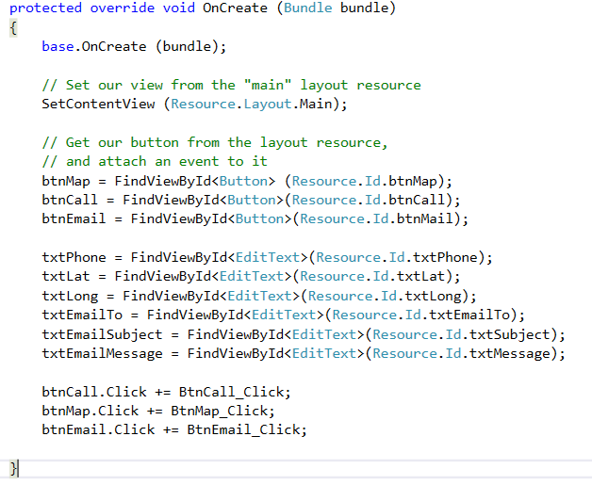

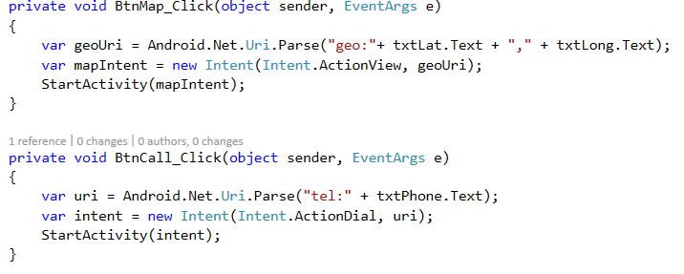

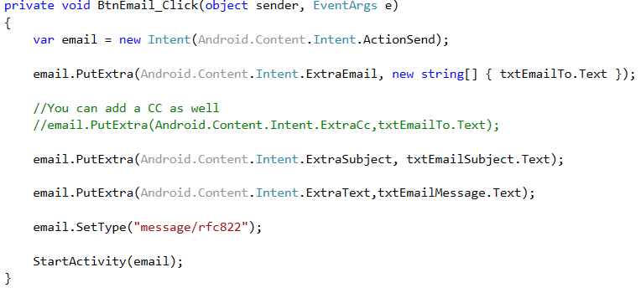

Read Image from a gallery using Intents and show it in an Image View (Xamarin Recipe)

[**https://developer.xamarin.com/recipes/android/data/files/selecting_a_gallery_image/**](https://developer.xamarin.com/recipes/android/data/files/selecting_a_gallery_image/)

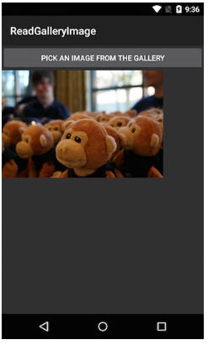

Add an ImageView to Main.axml:

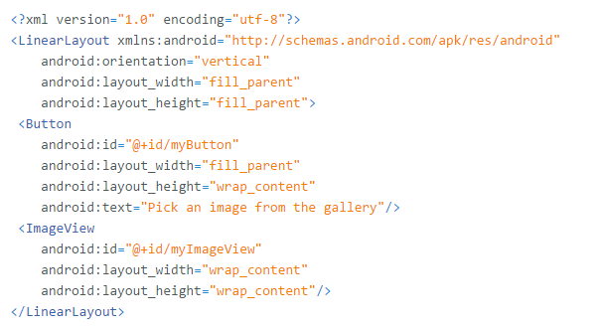

In an Activity subclass, create an Intent with a MIME type set to "image/*” and an action set to ActionGetContent. Pass the intent to a StartActivityForResult method call

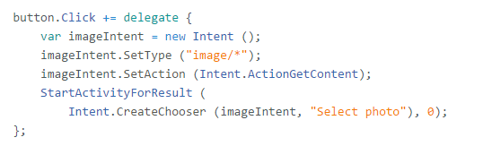Override OnActivityResult and set the image Uri of the ImageView to the Uri of the selected image.

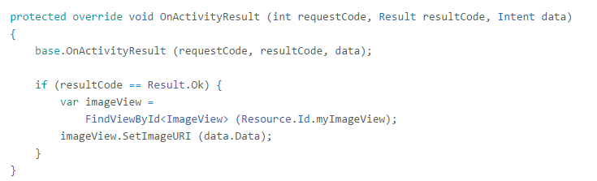

**Options Menu Demo**

The [options menu](https://developer.android.com/guide/topics/ui/menus.html#options-menu) is the primary collection of menu items for an activity. It's where you should place actions that have a global impact on the app, such as "Search," "Compose email," and "Settings."

Design a layout as shown below.

**Insert a full screen WebView.**

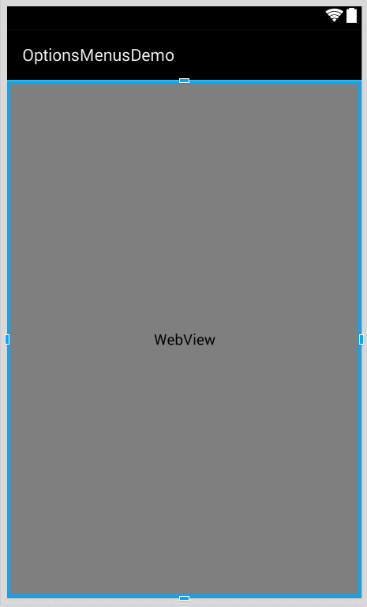

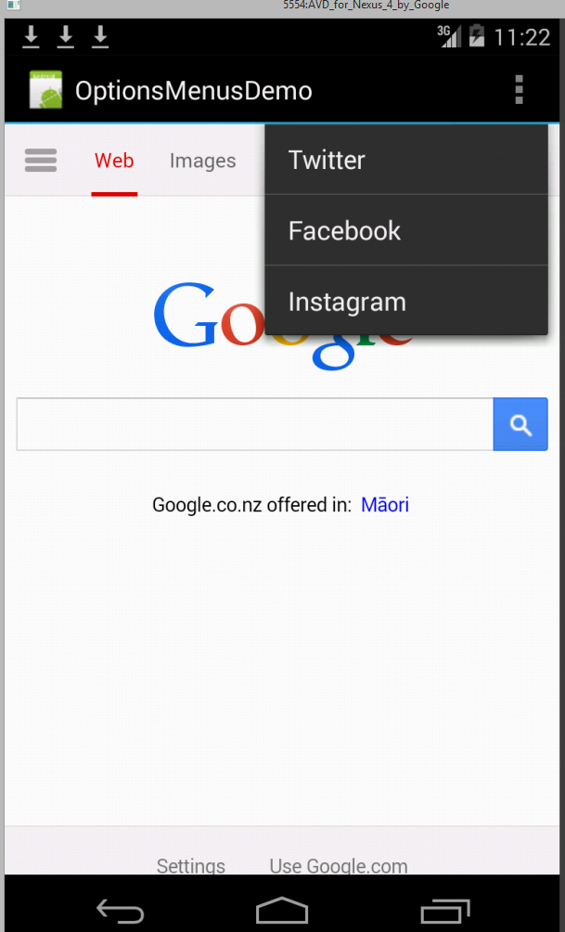

**MainActivity.cs**

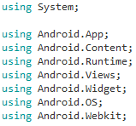

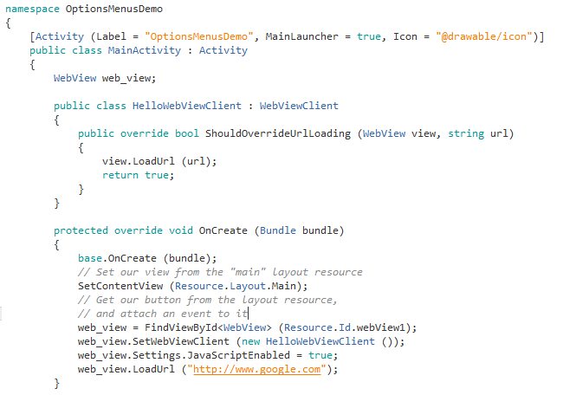

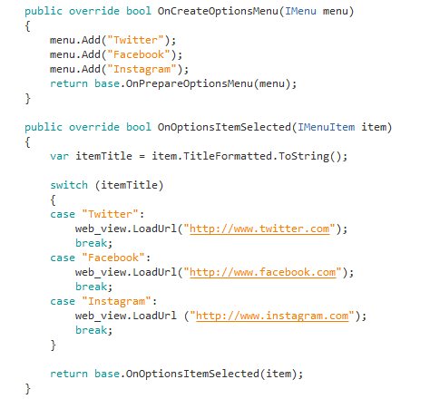

**Tab Layout**

A TabLayout is for displaying more than one view in a single view. The TabLayout works on selected tab. if the tab is selected, the respective view for it would be displayed.

**TabActivity**

A TabLayout could be achieved by using the TabActivity. In this example we would see four tabs such as Home, Events, People and Comments.

For each Tab, we need to have a Layout, an Activity.

If we want to add 4 tabs we need to add 4 layout files and 4 activities.

So let’s get started.

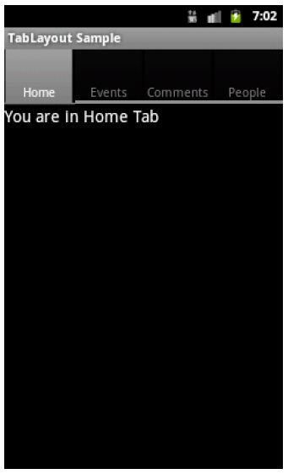

**Add four layout files**



The above Layout folder consists of all the above mentioned Layouts. For demo purpose each Layout has a TextView encapsulated inside a LinearLayout.

**Add four Activities**









**In the MainActivity.cs**



**Android Calendars and Date-time Pickers**

**Exercise**

Implement the Rock Scissors Paper game

